Ligaya SDG Attendance System

Step 1: Scan the QR Code:



[www.ligayasdg.org](http://www.ligayasdg.org)

Step 2: Fill in the details.

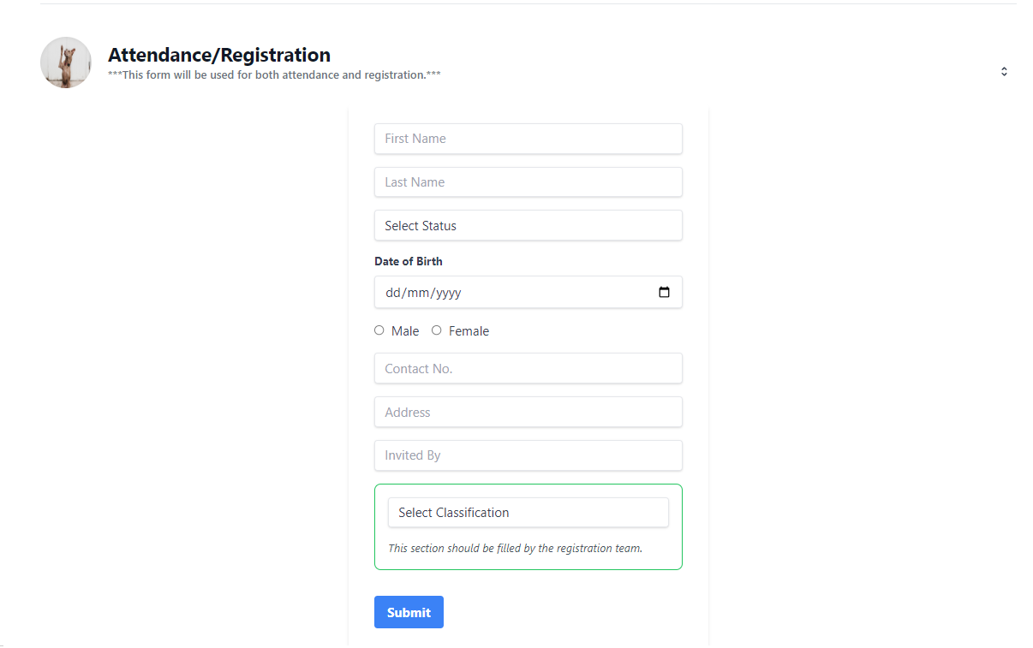

When participants enter their names in the First Name field, the system will automatically display matching names from the database for selection if they are already registered.

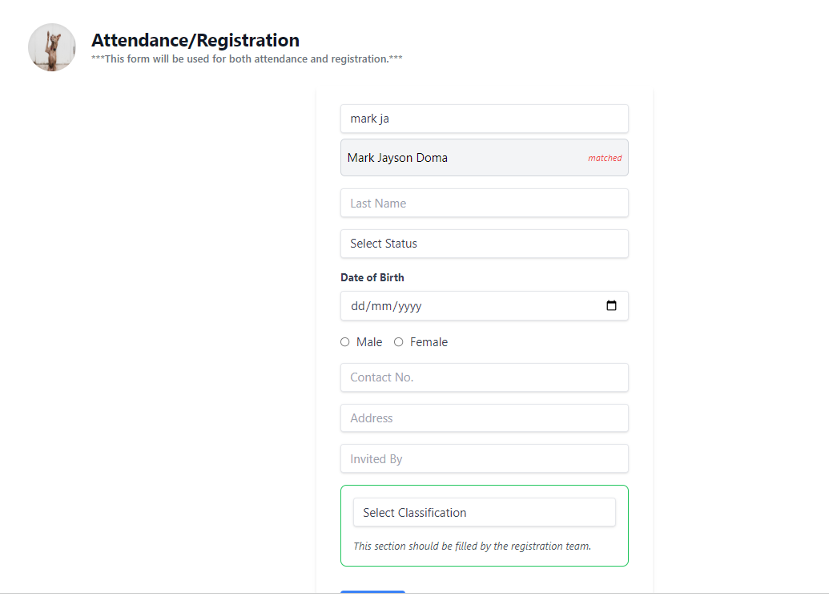

Step 3: Select the matched Name.

Step 4. Click “I’m Here!” to record the attendance.

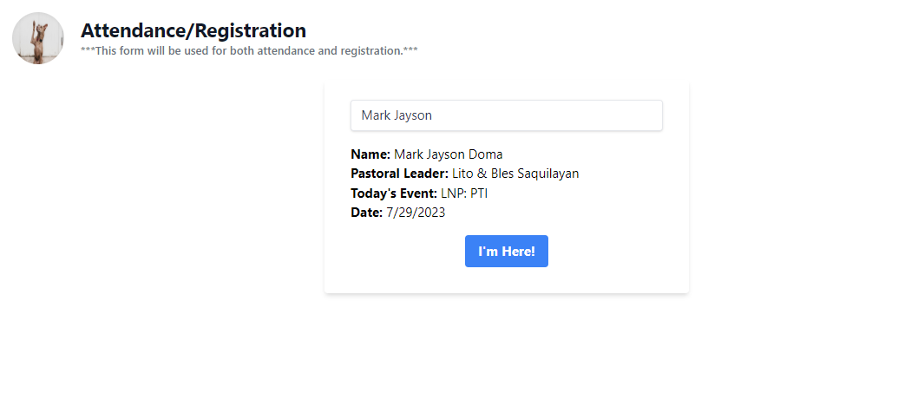

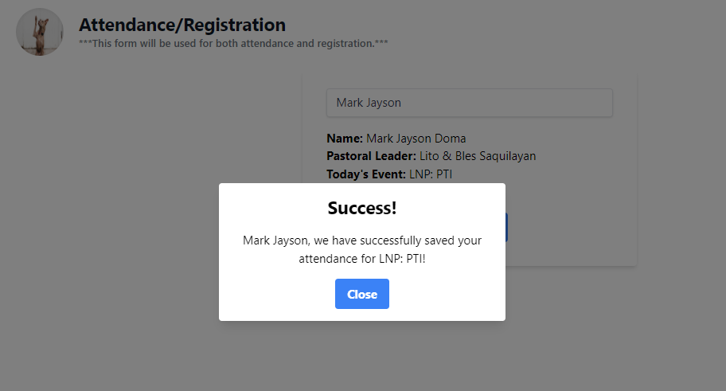

Real-time attendance will be recorded on the Summary Report Page.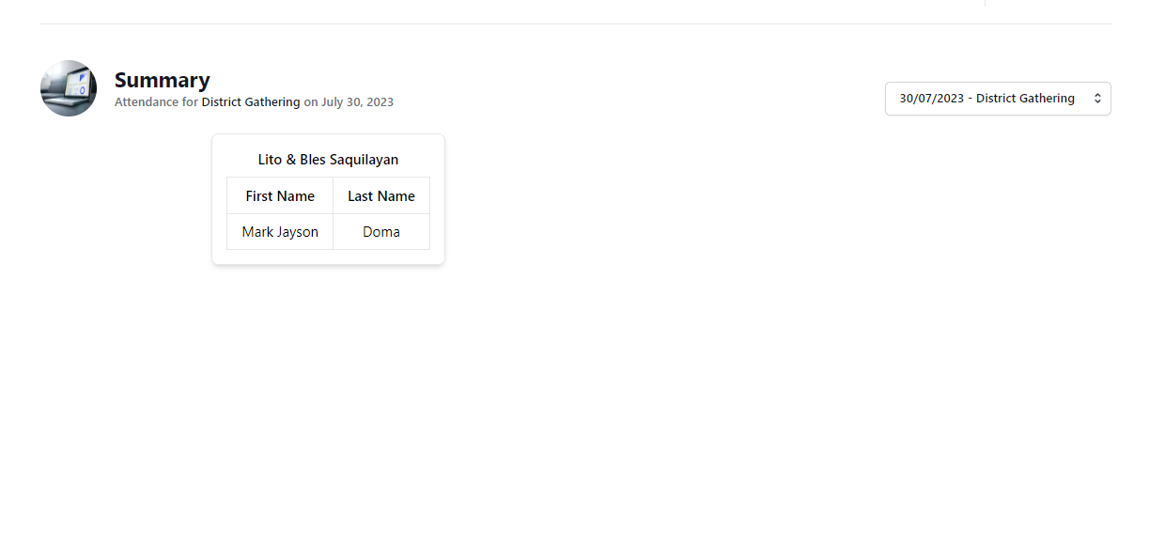

***For participants that are not in the database e.g. Guest, Non-SDG members***

Step 1: (same above)

Step 2: Fill in all the details:

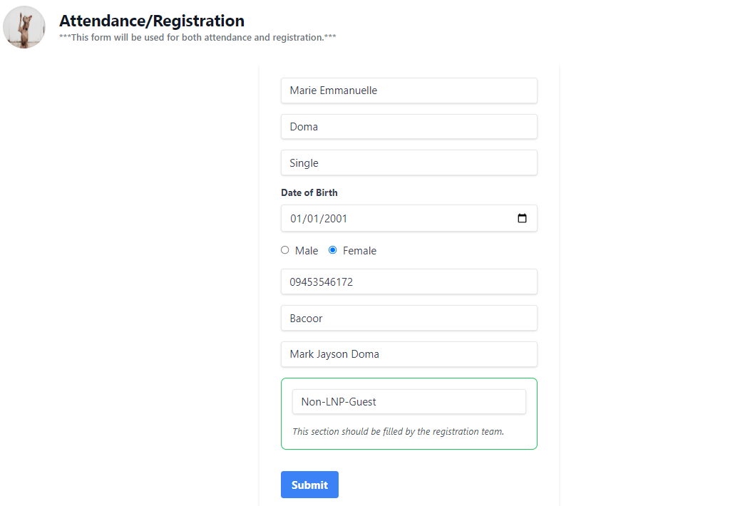

Step 3: Click Submit

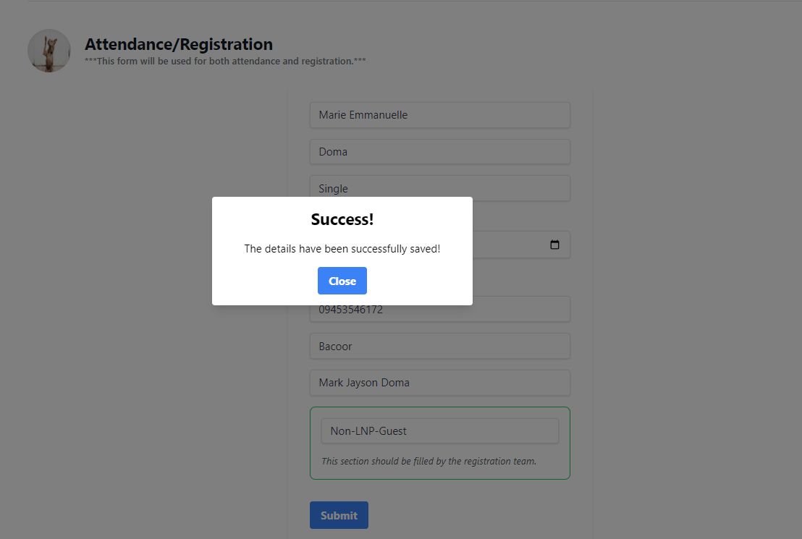

Step 4: The information, along with the day's attendance, will be saved in the database. Please refer to the Summary Report Page for more details.

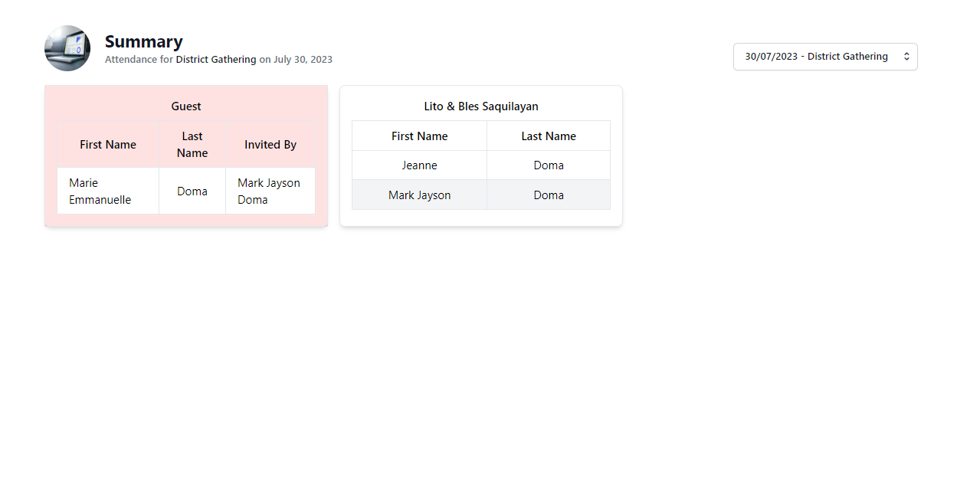

*** The report is organized based on the Pastoral Leader, and guests are also grouped with the information about who invited them.